SIL Converters 4.0 Installation
SIL Converters Pages
SIL Converters Home: http://scripts.sil.org/EncCnvtrs
SIL Converters 4.0 Installation: http://scripts.sil.org/EncConverters40inst
Encoding Conversion Frequently Asked Questions: http://scripts.sil.org/EncConvFAQ
Download: http://scripts.sil.org/EncCnvtrs#download
SIL Converters 4.0 Installation
Overview
Installation
Software prerequisites
SIL Encoding Converters Setup
SIL Converters for Office 2003
Converter Installer
Known issues at release time
CC Unrecognized keyword error
TECkit unexpected character: "?" at line 1 error
Python 2.5 required for Python script conversions
Perl 5.10.1 required for Perl expression conversions
EncConverters prior to version 4.0 Compatibility issue
Vista users upgrading to SILConverters 4.0
Vista Standard Users account installation

Overview
SIL Converters version 4.0 is intended to be installed using the Master setup program found at http://scripts.sil.org/EncCnvtrs#download.
This document is intended to guide you through the Master Installer installation screens and initial SIL Encoding Converters Setup. This guide may be sufficient for many users. However, to make full use of SIL Encoding Converters, you should refer to the SIL Encoding Converters documentation at: http://scripts.sil.org/SILConverters40_doc.
The Master Setup program runs a series of installers:
- Software prerequisites—Necessary system updates and add-ons are installed on your computer.
- SIL Encoding Converters Setup—Conversion applications are installed and conversion Maps and Tables are copied to your hard drive.
- SIL Converters for Office 2003—Currently this installer only installs an additional operating system update.
- Converter Installer—A utility that allows you to activate the conversion Maps and Tables you want to use.

Installation
If this is the first time you are running the installer, be sure to close all programs before starting the installation program, including the program that you are using to read this document. Several of the software prerequisite sub-installers will stop and tell you to shut down programs.
Suggestion: If this is your first time installing SIL Converters, you may want to print out this document to guide you through the process.

Software prerequisites
These installers may require that you answer some dialog box questions. Be sure to allow these updates and add-ons to be installed; they are necessary for SIL converters to run properly. Several of the software prerequisite programs may stop and tell you to shut down programs you were not even aware were running. Be sure you follow all instructions.
If it seems the installer has stalled, it may be there is a dialog box waiting for you to respond. However, be patient. Some of these installers take several minutes to finish.

SIL Encoding Converters Setup

Overview
This section is intended as a guide for initial setup. For detailed information on the SIL Encoding Converters Setup see Help for SIL Converters.
- You should probably choose all defaults, except if there is a Maps and Tables package that you might want to use.
Tip:
You do not need to know exactly what you want to install the first time you run the Setup program. You can run the Master Setup program again to add or delete components. For more information on the SIL Converters components and features see Help for SIL Converters.

Installation
- Welcome screen.
  - Click Next .
- Destination folder
  - To use the suggested folder (recommended), click Next .
For Advanced Users: As many of the components in the SIL Converters suite are shared utilities, the vast majority of the download will be installed in specific, fixed, shared locations. For example, most of the transduction engines are provided by DLL programs which must be in a folder that is in the Windows Path environment variable. For this reason, the TECkit, CC, ICU, Perl, and Python DLLs are put into the C:\Program Files\Common Files\SIL folder, which is also added to your system Path variable. However, the majority of the client applications, which otherwise don’t need to be in one of these shared locations (e.g. the Bulk SFM converter, the Clipboard EncConverter, etc), will be installed in the folder which you select from this dialog box.

Select features
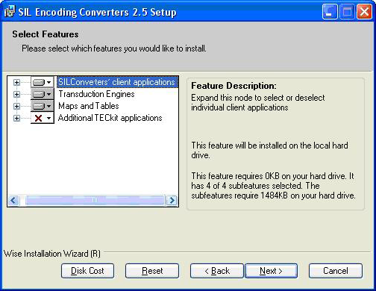
-
This screen allows you to select which conversion applications are installed and which conversion Maps and Tables are copied to your hard drive. Selected Map and Tables will need to be activated using the Converter Installer dialog latter in the installation process.
- Select Features—Alternatives:
  - To install the most commonly used features and components, click Next .
  - To install additional font conversion packages:
    - Select any any of the following packages listed under Maps and Tables:
      - FindPhone to IPA converters—converts FindPhone data to IPA93 or Unicode (one way conversion)
      - SAG (India)—converts between legacy SAG encodings and Unicode
      - Cameroon—converts between legacy SIL Cameroon encodings and Unicode
      - Central Africa—converts between legacy SIL Central African encodings and Unicode
      - East Africa—converts between legacy SIL East African encodings and Unicode
      - West Africa—converts between legacy West African encodings and Unicode
      - Eastern Congo Group—converts between legacy ECG encodings and Unicode
      - NLCI (India)—converts between legacy NLCI encodings and Unicode
      - Hebrew—converts between legacy SIL Hebrew encodings and Unicode
      - Indic Converters—converts between various non-SIL legacy Indic encodings and Unicode, including the new Scientific and Technical Hindi Google Group transducer.
      - Papua New Guinea—converts between various legacy PNG encodings and Unicode
    - When you see the popup menu choose Will be installed on local drive.
    - The SILConverters for Office application, which provides SILConverter support to the MS Office programs Excel, Publisher, and Access, will not install by default, nor even be visible in the feature tree if the Microsoft Programmable Interop Assemblies (PIAs) are not installed. Search in Help for SIL Converters for the string “PIA” for details on how to install these.
    - When you have finished selecting any additional Map and Tables, click Next .
- Click Next again to begin installation.
- When you see the SIL Encoding Converters 4.0 has been successfully installed message, click Finish to continue.

SIL Converters for Office 2003
The SIL Converters for Office 2003 Setup currently only installs a critical operating system update. However, the update is needed by all users, whether or not you have Office 2003.
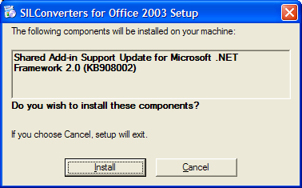
- Click Install .
Tip:
This installer will not run if the update is already installed.

Converter Installer
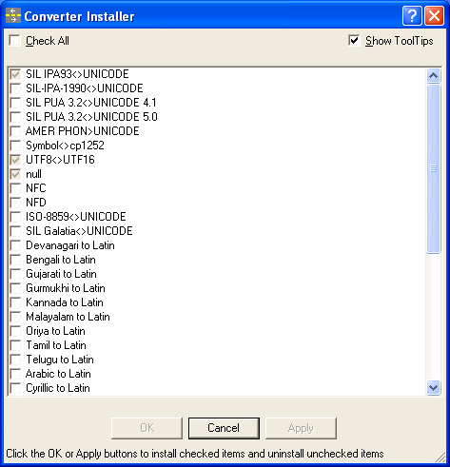
The Converter Installer allows you to add the converters you want to use to the system repository of your machine. This makes them available to all applications that use Encoding Converters.
- This selection menu is also permanently available from: Start / Programs / SIL Converters / Launch Converter Options Installer. All conversions currently copied to your hard drive are listed.
  - A gray check indicates conversions that are currently active
  - A dark check indicates conversions that are selected to be activated.
  - No check indicates conversions that are not activated or are selected to be deactivated.
- Check All: Click this box to cycle between
  - Check All,
  - Clear All, and
  - Show Currently Installed
- Show Tool Tips: When this box is checked, hovering over the conversion name will display information on the conversion.
  - Select the conversion you want activate. Most users will only use one or two conversions.
Tip:
Do not activate all the converters. Too many active converters will slow down your system considerably, particularly if you are using the Clipboard Encoding Converter application.
- Click OK or Apply to activate your selections.
- Click Cancel to finish.

Known issues at release time

CC Unrecognized keyword error
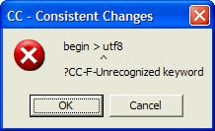
CC Error dialog box
If you see this error message: begin > utf8 ?CC-F-Unrecognized keyword, it means that there is a version of the file cc32.dll somewhere in your Windows Path that is older than the one installed by SIL Converters into the C:\Program Files\Common Files\SIL folder. It is best if you delete any older copy of cc32.dll. The existing application which installed it will be able to use the newer version installed by SIL Converters because it is also on the Path.

Alternatives
- Delete any versions of cc32.dll that may be in your C:\Windows\System32 and C:\LingLink\Cellar\Smv folders.
- Do a Search of your hard drive for cc32.dll and delete any versions older than 4/16/2002 (Version 8.1.6).
  - Click Start / Search.
    - Result: A Search Results window opens.
  - In the All or part of file name: drop down box, type or paste: cc32.dll.
  - In the Look in: drop down box, make sure Local Hard Drives appears.
  - Click More advanced options and make sure Search system folders is checked.
  - Click Search
    - Result: The search should find cc32.dll in C:\Program Files\Common Files\SIL as well as in some other locations on your hard drive.
  - Delete any versions of cc32.dll in folders other than C:\Program Files\Common Files\SIL.
    - Warning: If the search finds versions of cc32.dll in .zip or other compressed file folders, you should not try to delete them.

TECkit unexpected character: "?" at line 1 error
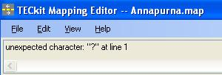
If you see an error while trying to use a TECkit map converter that says, "unexpected character: "?" at line 1", it means that there is an older version of the TECkit DLL files (i.e. TECkit_x86.dll and TECkit_Compiler_x86.dll) somewhere in your Windows Path that is older than the one installed by SIL Converters into the C:\Program Files\Common Files\SIL folder. It is best if you delete or rename these older versions of the DLL files. The existing application which installed them will be able to use the newer versions installed by SILConverters because they are also on the Path. See the Alternatives above for removing an obsolete CC32.DLL to find and remove any older versions of the TECkit DLLs not in the C:\Program Files\Common Files\SIL folder.

Python 2.5 required for Python script conversions
If you want to use a Python script converter, such as 'UnicodeName' (installed when you select the 'Python Script Functions 2.5' transduction engine feature in the SILConverters' installer), you must also install a separately-available Python distribution of the same version number.
SILConverters 4.0 supports encoding conversions using Python Version 2.5. This means you must have a Python Version 2.5.x. installed on your computer. It will not work with an earlier or later Python version (e.g. 2.4.1 or 2.6.2).
As of this writing, Python Version 2.5.4.4 is available for download from http://www.activestate.com/activepython or from their previous version download area http://downloads.activestate.com/ActivePython/windows/2.5/ActivePython-2.5.4.4-win32-x86.msi.

Perl 5.10.1 required for Perl expression conversions
If you want to use a Perl expression converter, you must also install a separately-available Perl distribution with a matching version number.
SIL Converters 4.0 supports encoding conversions using Perl Version 5.10.1. It will not work with any other Perl version (e.g. 5.8.8 or even 5.10.0). As of this writing, ActiveState Perl Version 5.10.1.1006 is available for download from http://www.activestate.com/activeperl/. It is also possibly available from their previous versions download area here: http://downloads.activestate.com/ActivePerl/Windows/5.10/).
Tip: If you are currently using the Perl add-in in SILConverters 3.0 (or FW 5.4.1), which is dependent on the Perl distribution v. 5.10.0, you will need to upgrade your Perl distribution to version 5.10.1 in order to use it in SILConverters 4.0 (or FW 6.0).
If you want to run both version simultaneously (e.g. the Perl add-in from SEC 3.0 (old) together with the Perl add-in from FW 6.0 (new)), you can, but you still need both Perl distributions 5.10.0 and 5.10.1 installed in separate folders (e.g. C:\Perl and C:\Perl5.10.1). For the former version programs (i.e. SEC 3.0 and FW 5.4.1), you’d use the path to the Perl 5.10.0 distribution and for the newer version programs (i.e. SEC 4.0 and FW 6.0), you’d use the path to the Perl 5.10.1 distribution.
You set the path to the distribution by clicking the Distro Config button in the configuration tab for the Perl expression add-in. For example, click Start, All Programs, Clipboard EncConverter, right-click on the system tray icon and choose, Add Converter, choose Perl Expression and click on the Setup tab to see item 4 this dialog:
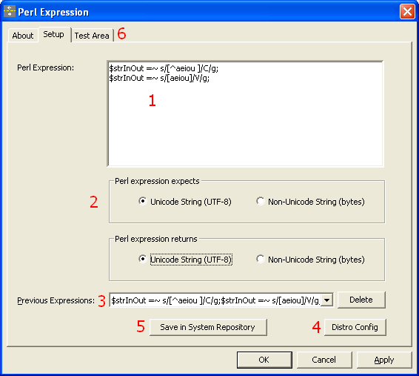

EncConverters prior to version 4.0 Compatibility issue
In the process of installing this new version of SILConverters, if you uninstall an earlier version of SILConverters (e.g. 2.6.1), then it will likely disable the use of EncConverters in any of the earlier client applications (e.g. FieldWorks prior to v5.4, Speech Analyzer 3.0.1, and the Phonology Assistant 3.0). These programs which use the earlier version of the EncConverters core can be fixed by re-running their installation programs and doing an installation Repair.
Technical Details:
Old and new versions of the EncConverter core can be installed and work together normally. However, if you subsequently uninstall any of the programs that use the older version, it will incorrectly remove some core registry settings that the remaining program(s) depend on. As a result, the older client programs, such as Fieldworks (prior to v5.4) or Speech Analyzer/Phonology Assistant, will lose EncConverters functionality until the registry settings are restored. Typical error messages may state “Encoding Converter not found” or “Error initializing Document reader”.
In addition to doing an installation Repair, the problem can be fixed by double-clicking on the RegisterSEC.bat file installed by some of those earlier client programs. You must execute the batch file while logged in to an administrative user account. On Vista, you can run it by right-clicking the batch file, then selecting ‘Run as Administrator’. RegisterSEC.bat can be found in the FieldWorks, Speech Analyzer, or Encoding Converters installation folder.
For those that know how, you can also fix the problem by using regasm to register SilEncConverters22.dll in c:\Program Files\Common Files\SIL\2.6.1.0 or 2.6.0.0 folder.

Vista users upgrading to SILConverters 4.0
Non-administrative Vista users may discover that some of their encoding converters, pictures, and media files are no longer available. This is due to Vista’s virtualization ‘feature’. For encoding converters, it is usually simplest to re-add the missing encoding converters.
Technical Details:
When a non-administrative Vista user creates a file under Program Files, instead of writing the files under Program Files, the files are created under c:\Users\YourLoginName\AppData\Local\VirtualStore\Program Files\ where YourLoginName is your Vista login name. If multiple users log on to a machine, there will be multiple, separate copies of these files. FieldWorks 4.9, Speech Analyzer 3.0.1, and SIL Encoding Converters 2.6.1 and later versions no longer write any files under Program Files, so this problem will be avoided. When upgrading from older versions of these programs, user files from Program Files are copied to the new location under c:\ProgramData\SIL. However, the installers do not catch files from these virtual directories. If you are missing encoding converters after an upgrade, you can copy the contents from the MappingFiles and Repository folders from your VirtualStore\Program Files\Common Files\SIL to similar directories under c:\ProgramData\SIL.

Vista Standard Users account installation
SILConverters 4.0 may be installed on a Vista Standard User account as long as Administrator credentials are provided in the UAC dialog that will be displayed when you attempt to install. However, there is problem with one of the Microsoft OS update packages not installing properly on Vista Standard User accounts. So, if possible, it's best to try to install SILConverters while logged into an Administrative account. If this is not possible, then at least it is necessary that you manually install the lockbackRegKey.msi installer by double-clicking on it in a Windows Explorer window.
Technical Details:
If you want to install SILConverters 4.0 while logged into a Standard User account on Vista, then after installation (and before attempting to open any Office 2003 or 2007 documents), you should manually run the following program by double-clicking on it in Windows Explorer: C:\Program Files\SIL\SILConverters\MS KB908002 Fix\KB908002\lockbackRegKey.msi. If you don't do this, then each time you open a Word document, for example, it will attempt to re-launch the SILConverters installer.
Contact mailto:silconverters_support@sil.org for limited support.

